DR. D.Y. PATIL PRATISHTHAN'S COLLEGE OF ENGINEERING.
Department of Computer Science & Engineering
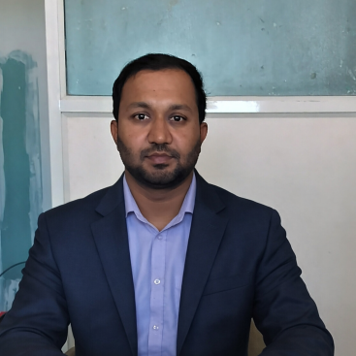 | Name : | Ajit R.Chougale
 | Designation : | Assistant Professor
 | Qualification : | M.Tech CSE(Data Science)
 | Experience : | Total Experience :9 Years  - Teaching experience :8 Years  - Industrial experience: 1Years
 | Area of Interest For Research : | • Computer Networks  • Network Security  • Machine Learning  • Data Science
 | Courses Taught : | Compiler Construction, System Programming, Operating System, Computer Network, Network Security.
 | Publications : | - International Journal: 2  - National Journal: Nil  - Patent-01
 | Workshops/Conference Attended : | - FDP: 08,  - National Conference: 01  - STTP:2  - Webinar:6
 | Professional Memberships : | - Indian Society for Technical Education(ISTE)
 | E-Mail : | AjitChougale.coes@dypgroup.edu.in

